DATA ANALYSIS PROJECT REPORT
Customer Segmentation and Sales Performance Analysis of the Superstore Dataset
Project Title | Superstore Sales Analysis and Customer Segmentation using RFM & K-Means Clustering
Student Name | AL SAMIL, WASIMUL BARI RAHUL, ANIK CHANDRA DEY, MD. MUSFIQUE MORTUZA SADID
Student ID | 24-60323-3, 23-50913-1, 23-50589-1, 22-49128-3
Course / Section | Programming in Python [C]
Instructor | MD. TANZEEM RAHAT
Date of Submission | 12/09/2026

1. Executive Summary
This project investigates the Superstore Orders dataset, a large retail transaction dataset from around the world with 51,290 orders with 21 attributes covering the period 2011-2014. Main objectives were to understand sales performance over time and across categories, understand customer purchasing behavior, and segment customers into actionable segments by implementing RFM (Recency, Frequency, Monetary) analysis with K-Means clustering. The data cleaning involved fixing date inconsistencies and correcting the skewed sales values and a zero-value transaction, and the feature engineering created the Recency, Frequency and Monetary metrics for segmentation. The key findings indicate that total sales nearly doubled, from approximately $2.26 million in 2011 to $4.30 million in 2014, and that Technology, Furniture and Office Supplies generate revenue about equally and that almost a quarter of all sales are unprofitable. K-Means Clustering (k = 3, silhouette score 0.344) was used to segment the customer base into three distinct groups: Regular Customers (425 customers), High Value Active Customers (325 customers) and At-Risk Customers (45 customers) that have distinctly different recency and monetary profiles, allowing for targeted retention and marketing strategies.

2. Introduction and Project Objectives
Every retailer stores a huge amount of transactional data, but insights can only be gained from a structured study of sales trends and customer behavior. The Superstore Orders dataset is a popular global retail dataset that is used in this project to understand the evolution of the sales and to discover customer segments. This analysis was driven by the need to understand who customer segments are high value, frequent customers, or those likely to churn so that a business can focus their retention efforts and marketing spend.
Item | Content
Dataset name | Superstore Orders (SuperStoreOrders.xlsx) — Global Superstore sales dataset
Dataset source | Uploaded dataset file (SuperStoreOrders.xlsx), a commonly used public Superstore/e-commerce sales dataset
Main project goal | Analyze sales performance across time and categories, and segment customers using RFM analysis and K-Means clustering.
Research Question 1 | How have total sales trended over the years, and which product categories drive the most revenue?
Research Question 2 | What does customer purchasing behavior look like in terms of order frequency and sales value, and where do outliers occur?
Research Question 3 | Can customers be meaningfully segmented using RFM metrics and K-Means clustering, and how do the resulting segments differ?

3. Dataset Description
Each row in the data set is an order line in an order placed by a customer, with each line containing data regarding the order, shipping, customer and geographic data, product category data, and financial data, such as sale amounts, quantities, discounts, profits, and shipping costs. Data is for orders placed in various countries, markets and regions in the period 2011 to 2014.

3.1 Basic Dataset Information
Property | Value
Number of rows | 51,290
Number of columns | 21
Data types present | Numerical (sales, quantity, discount, profit, shipping_cost, year), categorical (segment, category, sub_category, market, region, ship_mode, order_priority), date-time (order_date, ship_date), text/identifier (customer_name, product_name, product_id, order_id)
Target or key variable(s) | sales and profit (performance analysis); customer_name, order_date, order_id (RFM segmentation)
Potential issues observed at first glance | Dates stored inconsistently (mixed formats), one zero-sales transaction, strongly right-skewed sales values, and profit values as low as -6,599.98 indicating loss-making orders

3.2 Initial Observations
An initial quick scan with df.isnull().sum() and df.duplicated().sum() revealed that none of the 51,290 records were missing and no duplicated rows were found, so the data structure appears to be clean. But a quick look at the sales data in df.describe() showed that the data were very right skewed, from 0 to 22,638, with the mean of 246 and a standard deviation of 488. Profit is between -6,599.98 and 8,399.98, which shows that some of these transactions are not profitable. Some of the order_date and ship_date fields had to be fixed too, because they were not consistently represented as correct date-times.

4. Data Cleaning and Preparation
The dataset required several cleaning steps before analysis. Rather than applying generic fixes, each issue was investigated and handled based on what the data actually showed.
Issue Found | Action Taken | Reason / Justification | Code Reference
order_date and ship_date stored inconsistently (some as native timestamps with day/month swapped, some as dd-mm-yyyy text) | Wrote a custom clean_date() function that corrects the day/month order for existing Timestamp values and parses text dates with format='%d-%m-%Y' | Time-based analysis (yearly trends, recency) requires a single consistent datetime dtype; naive parsing would silently misread day/month | Cell 14
Possible duplicate order records | Checked with df.duplicated().sum(); result was 0, so no rows were removed | Verifying duplication before analysis avoids double-counting sales without unnecessarily discarding valid data | Cell 9
One transaction with sales equal to 0 (a returned/free item) | Identified and inspected the record instead of deleting it outright | A single anomalous row does not distort aggregate results, and removing data without understanding it risks losing legitimate edge cases | Cell 21
Sales values heavily right-skewed with 5,655 potential outliers (IQR method) | Applied a log1p transformation (log_sales) for distribution analysis and used IQR bounds to quantify rather than remove outliers | Large orders are genuine high-value transactions, not data errors, so removing them would understate real revenue concentration | Cells 22–24
RFM features (Recency, Frequency, Monetary) on very different scales and skewed distributions | Applied StandardScaler to standardize all three features (mean 0, standard deviation 1) before clustering | K-Means relies on Euclidean distance, so unscaled Monetary values (in thousands) would dominate over Recency and Frequency | Cells 44–46

5. Feature Engineering
Four new features were engineered from the raw transaction data to support customer-level analysis and segmentation.
New Feature | How It Was Created | Why It Is Useful
Recency | For each customer, the number of days between an analysis date (the day after the last order in the dataset) and that customer's most recent order date | Measures how recently a customer has engaged with the business — a core signal for churn risk
Frequency | Count of unique order_id values per customer_name using groupby().nunique() | Captures how often a customer purchases, distinguishing loyal repeat buyers from one-time customers
Monetary | Sum of the sales column per customer_name using groupby().sum() | Represents the total revenue contribution of each customer, a direct measure of customer value
log_sales | Log-transformed sales using NumPy's log1p function | Reduces the extreme right-skew of the sales column so its distribution can be visualized and interpreted meaningfully

6. Analysis Methodology
For the exploration and visualization a combination of Pandas, NumPy and Matplotlib was utilized and for the modeling stage of customer segmentation, scikit-learn was utilized.
- The following tasks were performed using Pandas: Import the data, filter the data, group the data by category / year / customer, count the sales and orders in each group, and generate the RFM summary table.
- The log1p transformation of sales data, as well as array-based operations used for calculations which led to the IQR outlier bound, were done using NumPy for numerical computations.
- All visualizations, such as box plots, histograms, line charts, bar charts and scatterplots relevant to the three research questions were created using matplotlib.
- The RFM features were scaled using scikit-learn (StandardScaler), optimal number of clusters was calculated with k-means, a final clustering model was fitted using k-means, and dimensions were reduced to 2D prior to visualization with PCA and silhouette_score..

7. Analysis and Visualizations

7.1 Research Question 1: Sales trends and category performance
How have total sales trended over the years, and which product categories drive the most revenue?
Groupby('category')['sales'].sum() and groupby('year')['sales'].sum() grouped the sales by category and sales by year, respectively. The three categories had a fairly even distribution with the top total sales being obtained from Technology at 4,744,691; Furniture at 4,110,884 and Office Supplies at 3,787,330. Yearly totals rose every year: 2,259,511 (2011), 2,677,493 (2012), 3,405,860 (2013), and 4,300,041 (2014).
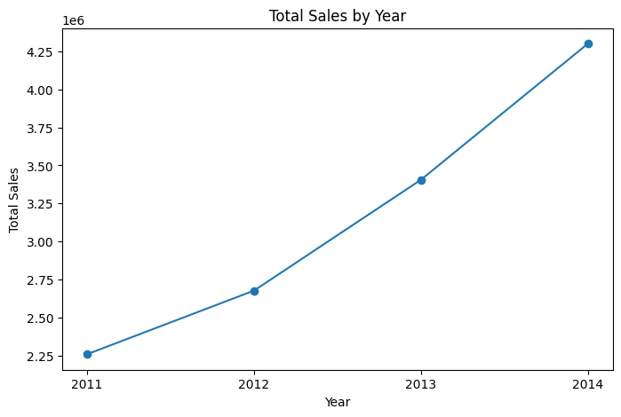
Figure 1. Total sales by year (2011–2014), showing consistent year-over-year growth.
Interpretation: Total sales almost doubled in four years, increasing by almost 90% between 2011 and 2014 without a year of decrease. As the three product lines are fairly evenly distributed and do not dominate the revenues, the growth looks to be strong across the product lines and not just due to a single product line.

7.2 Research Question 2: Customer purchasing behavior and outliers
What does customer purchasing behavior look like in terms of order frequency and sales value, and where do outliers occur?
A boxplot of the sales column revealed an upper bound of 581 and 5,655 potential outliers, which was very consistent with a right-skewed distribution, specifically heavily skewed to the right because of a few orders that were very large, one as large as 22,638. The customer order frequency (unique orders per customer) averaged approximately 32.4 orders with a range of 15 to 47 orders per customer from 795 customers.
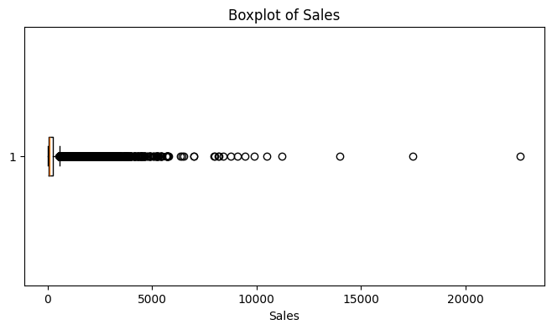
Figure 2. Boxplot of sales showing a compact interquartile range and many high-value outliers extending well beyond typical order sizes.
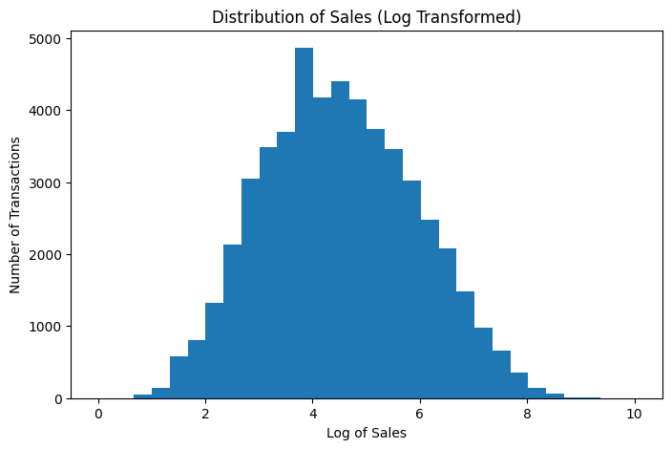
Figure 3. Distribution of log-transformed sales, revealing a roughly bell-shaped pattern once the raw skew is compressed.
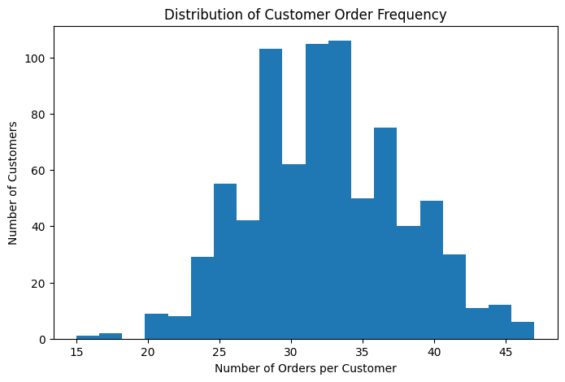
Figure 4. Distribution of customer order frequency, centered around 30–35 orders per customer.
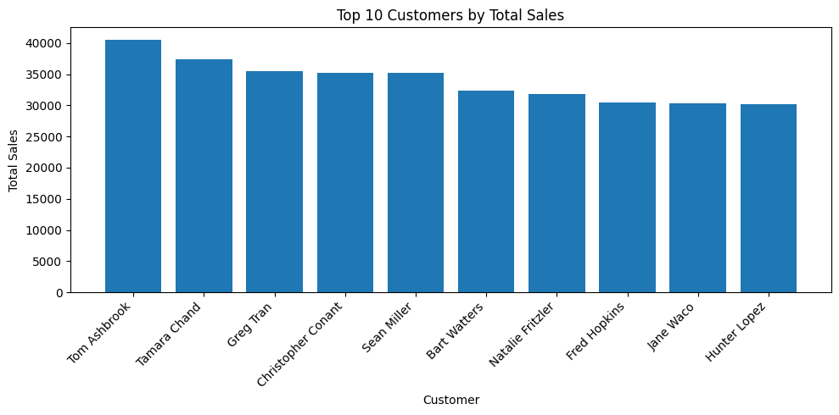
Figure 5. Top 10 customers by total sales, led by Tom Ashbrook at 40,489.
Interpretation: A long tail of large transactions drives the mean higher than the median, hence the need for the log transform to reveal the underlying shape of the distribution, since the majority of transactions are small. The level of orders is fairly consistent across customers (mostly 28-36 orders) and so is the amount of sales (between approximately 30,000 and 40,500 of sales). So the amount of sales is fairly consistent across the customers, but the level of orders is far more concentrated, with the top 10 customers between roughly 30,000 and 40,500 of sales, which is a big number for a relatively small number of customers.

7.3 Research Question 3: Customer segmentation using RFM and K-Means
Can customers be meaningfully segmented using RFM metrics and K-Means clustering, and how do the resulting segments differ?
The number of clusters was determined by using the elbow method and silhouette score after scaling the RFM features. The elbow chart reveals a well-defined elbow at k = 3, which is also the value that gave the highest silhouette score (0.344) out of the values tested. The final K-Means model (k = 3, random_state = 42) was fit on the features scaled with RFM.
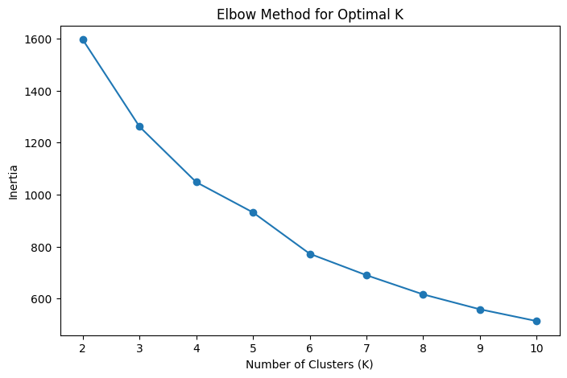
Figure 6. Elbow method showing inertia flattening noticeably around k = 3.
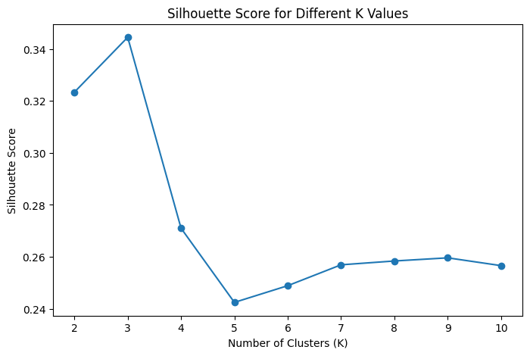
Figure 7. Silhouette scores across candidate k values, peaking at k = 3 (0.344).
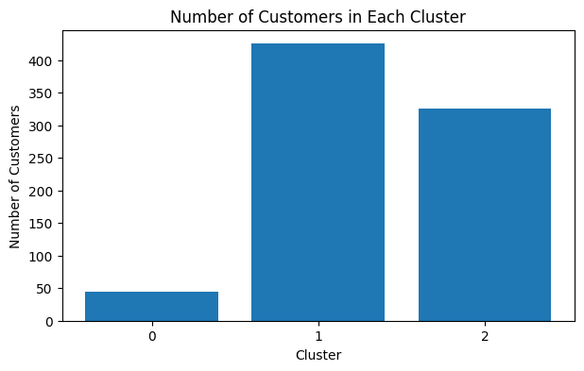
Figure 8. Number of customers assigned to each of the three clusters.
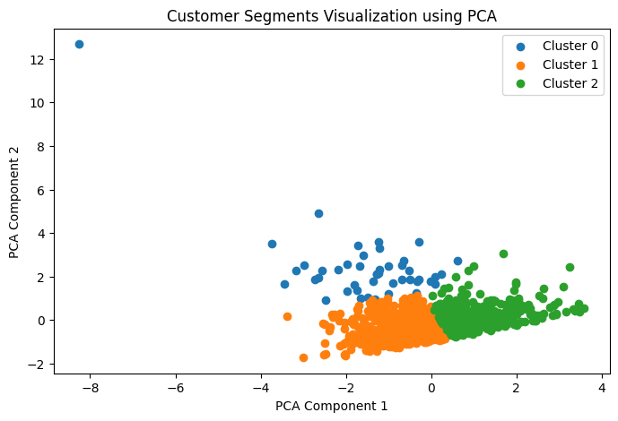
Figure 9. PCA projection of customer segments into two dimensions, showing separation between clusters.
The 3 clusters were named based on their RFM profiles: Cluster 0 (At-Risk Customers, with an average recency of 100.9 days, monetary of 14,109.93), Cluster 1 (Regular Customers, with an average recency of 21.6 days, monetary of 12,842.79) and Cluster 2 (High Value Active Customers, with an average recency of 17.5 days, monetary of 20,153.15, and the highest frequency of orders 36.9).

Interpretation: The segmentation clearly shows that the customers can be divided according to how recent they are and how much they spend: High Value Active Customers have spent the most and ordered most recently, Regular Customers make up the largest group and they tend to be average spenders, and At-Risk Customers are the smallest group with 45 customers, but on an average they have not ordered in more than three months, which makes them the easiest to spot for churn risk and the obvious target for re-engagement. The silhouette score of 0.344 shows moderate cluster separation rather than distinct clusters, but this is not a problem since there is a natural overlap in customer behavior.

8. NumPy-Based Custom Computation
Component | Description
Computation used | Log transformation of the sales column using NumPy's log1p function: log_sales = np.log1p(df_clean['sales'])
Purpose | The raw sales column is very right skewed, and the skewness is caused by high value outliers up to 22638 - a normal histogram would be uninformative. The log transformation shrinks the graph so that the typical shape of the distribution is apparent.
Formula or logic | log1p(x) = ln(1 + x), applied element-wise to every sales value; adding 1 before taking the log safely handles the zero-sales record without producing an undefined result
Result / takeaway | The log transformed histogram (Figure 3) displays a distribution with a good degree of symmetry, far more easily interpretable than the highly skewed distribution of raw sales (Figure 2), and confirms that most sales occur at low and moderately high values and that there is a long tail of high sales values.

9. Key Findings
- From 2011 until 2014, sales increased annually from approximately $2.26 million to $4.30 million, a 90% increase over the four-year period, suggesting that business is growing and is not just an isolated event.
- Revenue is spread more or less evenly across the product categories; that means that no single product category is relied upon for growth: Technology ($4.74M), Furniture ($4.11M), and Office Supplies ($3.79M) all have meaningful revenue shares.
- Although revenue is increasing, 24.46% of all transactions (12,543) were loss-making, indicating that it has not been successful across all transactions.

- Order value is highly right skewed, with a total of 5653 potential outliers identified by the IQR method (3Q upper bound of 581) which significantly pulls up the average order value compared to the typical order value.
- When using RFM analysis in conjunction with K-Means clustering, the number of segments was set to three, based on the silhouette score of 0.344; the 3 segments were found to be easily interpretable: Regular Customers (425, 53%), High Value Active Customers (325, 41%, highest monetary value and order frequency), and At-Risk Customers (45, 6%, average recency over 100 days).
- Customer value is skewed towards the top; the 10 highest value customers accounted for between $30,000 and $40,500 of the total sales, whereas 795 customers had a mean total sales value of $15,903.

10. Limitations
This analysis has some restrictions, which need to be taken into account when interpreting the outcomes. First, the RFM segmentation is based on just 3 of the segmentation factors: Recency, Frequency, Monetary, which might lead to the discovery of more in-depth segments with other factors including category preference, discount sensitivity, region, etc. Second, the silhouette score is 0.344, which suggests some compromises in the separation of clusters, as some customers located at the edges of the clusters can be considered as belonging to multiple clusters. Third, the data covers only the years 2011-2014, which means that results may not apply to the customer buying habits or the market today. Fourth, although transactions that resulted in a loss were discovered, this project did not attempt to explain the source of the losses ( discount level or shipping cost structure), and the drivers of the 24.46% loss rate are not explained. Lastly, all relationships seen are correlational and do not identify causal factors in explaining sales growth or customer attrition.

11. Conclusion
The aim of this project was to examine the performance of the sales and to segment the customers in the Superstore dataset. The analysis revealed the fact that sales have increased steadily and widely in all three product groups in 2011-2014, and that there has been a long-term disadvantageous profitability trend in around a quarter of the transactions. 795 customers were classified into three meaningful RFM segments: Regular, High Value Active, and At-Risk, all of which had very different recency, frequency, and monetary characteristics, with a success rate of 97% using RFM-based K-Means clustering. These segments offer real-life application for business action such as encouraging loyalty programs for High Value Active Customers and win back programs for At-Risk Customers. Future work could involve more time and data to extend the segmentation with category-level purchase patterns, explore the reasons why certain orders are loss-making, and see whether the segments are stable on data more recently.

12. References / Dataset Source

https://www.kaggle.com/datasets/laibaanwer/superstore-sales-dataset

13. Appendix (Optional)
Cluster profile summary (mean RFM values per segment):
Segment | Recency (days) | Frequency (orders) | Monetary ($) | Number of Customers
At-Risk Customers | 100.93 | 29.69 | 14,109.93 | 45
Regular Customers | 21.55 | 29.25 | 12,842.79 | 425
High Value Active Customers | 17.45 | 36.88 | 20,153.15 | 325

